Gerund Phrase

✅ Definition:
# Source: Chatgpt (GPT-4-turbo) at [7/28/2025]
A gerund phrase is a group of words that begins with a gerund (a verb ending in -ing that functions as a noun) and includes any modifiers or complements.
The entire phrase acts as a noun in the sentence.

🧩 Structure of a Gerund Phrase:
# Source: Chatgpt (GPT-4-turbo) at [7/28/2025]
Gerund + modifiers/complements
🔹 Eating ice cream on a hot day
🔹 Running every morning before sunrise

✏️ Examples of Gerund Phrases in Sentences:
# Source: Chatgpt (GPT-4-turbo) at [7/28/2025]
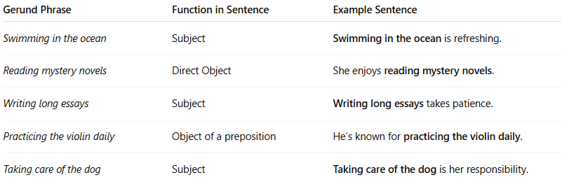
Gerund Phrase | Function in Sentence | Example Sentence
Swimming in the ocean | Subject | Swimming in the ocean is refreshing.
Reading mystery novels | Direct Object | She enjoys reading mystery novels.
Writing long essays | Subject | Writing long essays takes patience.
Practicing the violin daily | Object of a preposition | He’s known for practicing the violin daily.
Taking care of the dog | Subject | Taking care of the dog is her responsibility.

🎯 Functions of Gerund Phrases:
# Source: Chatgpt (GPT-4-turbo) at [7/28/2025]

Function | Example
Subject | Running long distances is tiring.
Object | I love eating spicy food.
Subject complement | Her favorite hobby is painting landscapes.
Object of preposition | They talked about moving to the city.

🔧 Components of a Gerund Phrase:
# Source: Chatgpt (GPT-4-turbo) at [7/28/2025]
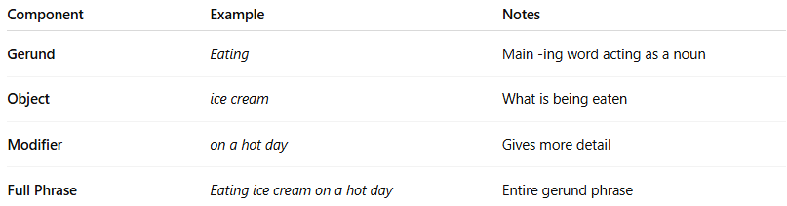

Component | Example | Notes
Gerund | Eating | Main -ing word acting as a noun
Object | ice cream | What is being eaten
Modifier | on a hot day | Gives more detail
Full Phrase | Eating ice cream on a hot day | Entire gerund phrase

⚠️ Don’t Confuse With:
# Source: Chatgpt (GPT-4-turbo) at [7/28/2025]
- Present participle phrases act as adjectives, not nouns.
➤ Running quickly, he caught the train. → Running quickly modifies he.
- Gerund phrases act as nouns.
➤ Running quickly every day keeps me healthy. → Whole phrase is subject.

🧠 Summary Table:
# Source: Chatgpt (GPT-4-turbo) at [7/28/2025]
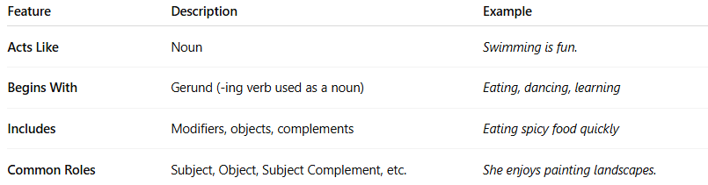
Feature | Description | Example
Acts Like | Noun | Swimming is fun.
Begins With | Gerund (-ing verb used as a noun) | Eating, dancing, learning
Includes | Modifiers, objects, complements | Eating spicy food quickly
Common Roles | Subject, Object, Subject Complement, etc. | She enjoys painting landscapes.

